Using Musictheory.net Mr. Kirk
- After logging onto computer, go to www.musictheory.net
- Find and click the “EXERCISES” tab.
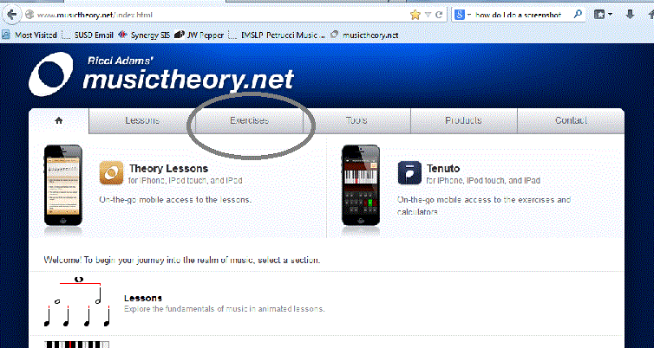

- Select first exercise, NOTE IDENTIFICATION

- You may need to customize the exercises. From the right side near the top, click on the middle button shown:

- If needed, click on “CLEFS” to change or add clefs. Violins use TREBLE. Violas use ALTO. Cellos use BASS. Pianos use TREBLE and BASS Clefs. Don’t forget to unselect clefs you don’t want. Click on back arrow to go back.
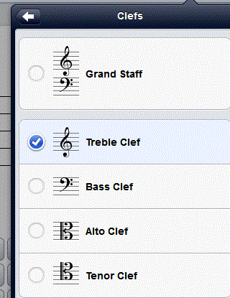
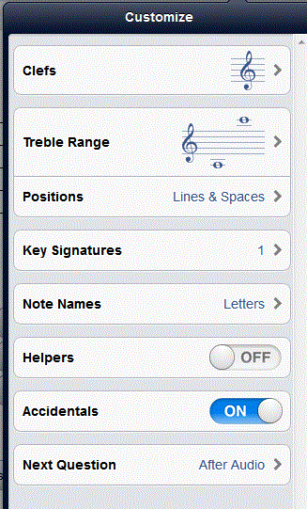

- Select appropriate note range. Look for your instrument range here and click on arrows to adjust. Click on the back arrow to go back:
Violin Viola Cello Bass
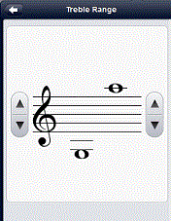
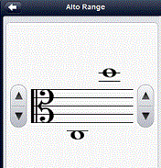
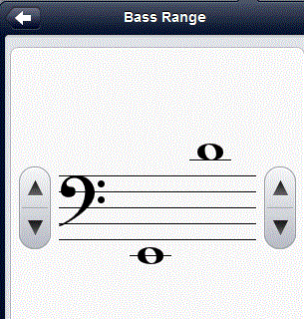
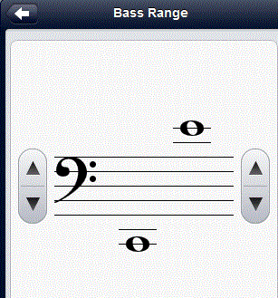

Piano C position only Piano Full Notes
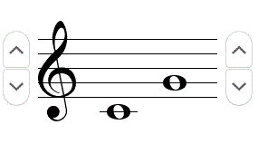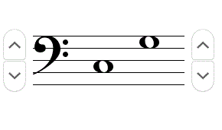

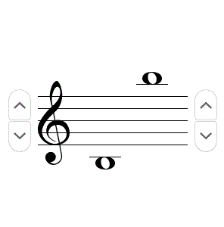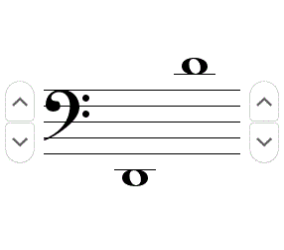

- Turn ACCIDENTALS off

- Change NEXT QUESTION from AFTER AUDIO to IMMEDIATELY

- Click on the settings button to begin identifying notes
- When you are ready to send your report to Mr. Kirk, click on the “i” button
- Select SHOW PROGRESS REPORT
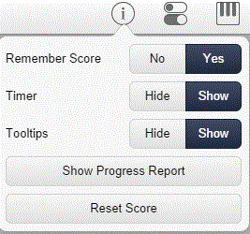

- Sign your name using your FIRST, LAST, and CLASS NUMBER (e.g. Joe Smith 416)
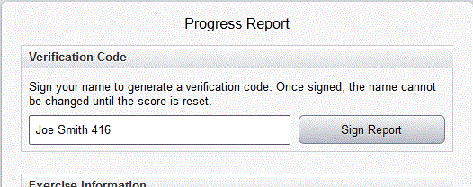

- You will receive a unique verification code. Right click your mouse and copy this code. You may then copy it to an email to send to Mr. Kirk.
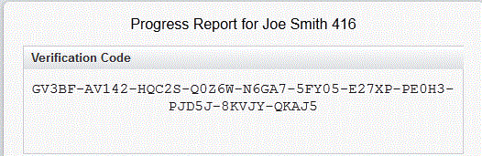

- Send your email to Mr. Kirk at the following address:
ikirk@stockton.k12.ca.us

- For the subject of your email, put your name and class number (e.g. Joe Smith 416). In the body of the email, paste the verification code you obtained in step 13.
- For each assignment, please reset your score.

- If you are unable to send an email,
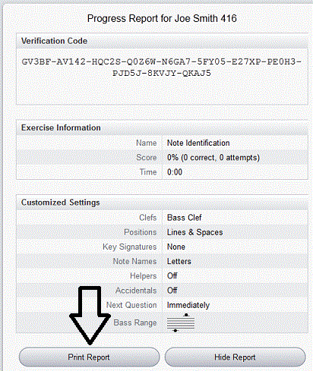
you may also print out progress report.

